(Approx. 198 words)

Nexar Beam Dash Cam
By George Harding, Treasurer, Tucson Computer Society
https://aztcs.apcug.org/
actuary110 (at) yahoo.com

This product is useful and installs with minimum effort.

It is a plug-and-play dashcam that installs behind the rear-view mirror.

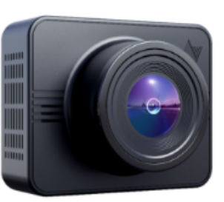

It records 1080p full HD video, which gives you a vivid 135-degree picture of the view from your windshield. Recording can be up to 4 hours.

A nice feature is the parking mode. Here, you get 24/7 security, and the dashcam can sense any impact and starts recording instantly. In addition, recorded footage can be downloaded to your cell phone for viewing. The included GPS feature even retains the vehicle location.

The companion app allows for live or delayed viewing of footage. In addition, recordings are backed up to the cloud, making them easy to use.

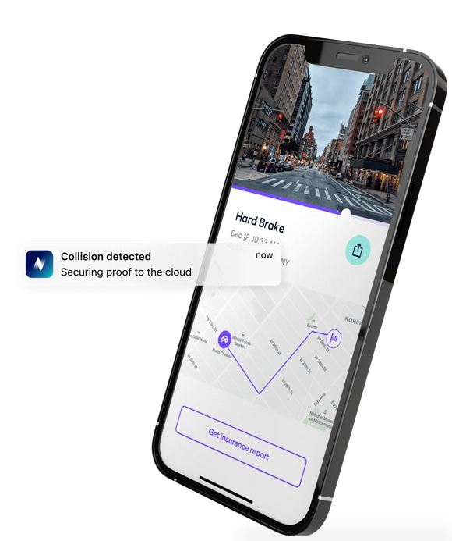

The dashcam comes with a 32GB microSD card, which can be upgraded if desired. In addition, unlimited, free cloud storage means that even if the dashcam is lost or stolen, the recordings can still be viewed and accessed from anywhere.

This is a really nifty device that is useful and maybe the key to proving liability in an accident.

Nexar Beam Dash Cam
https://shop.getnexar.com/products/nexar-beam-gps-dash-cam

Priced at $140

